How to connect to the network

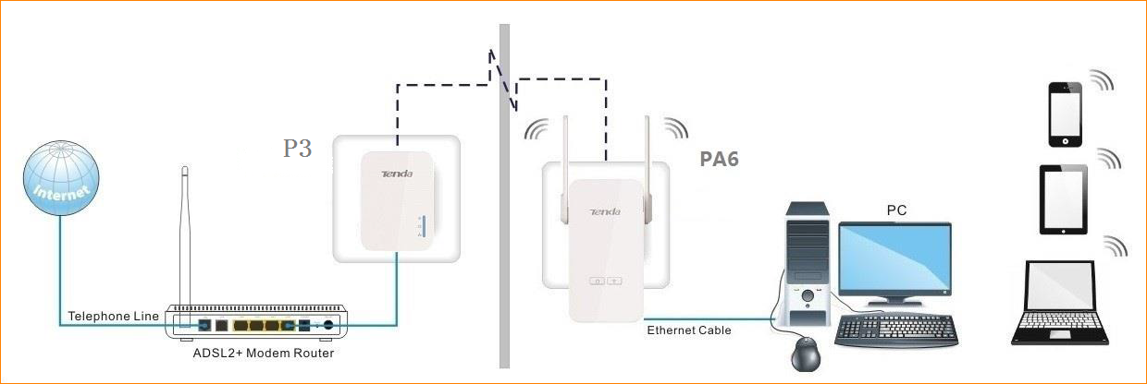
- Connect one powerline adapter (such as P3) to any LAN port of your router via an Ethernet cable and plug it into a wall outlet nearby.

- Plug the wireless extender（PA6） to your chosen place. When both of the PLC LED indicators on the powerline adapter and wireless extender turn solid, a powerline network is established.

- Connect your wireless devices or computer (with wireless adapter) to the wireless extender（PA6） wirelessly or via an Ethernet cable.

- The default WiFi name is Tenda_XXXXXX, which can be found on the rear panel of the extender（PA6）. And there is no default WiFi password.

